Masterpieces and Monuments presents:
Venice: La Serenissima
Wednesday February 12 to Thursday February 13
Cost: 450 euros for 2 days in Venice
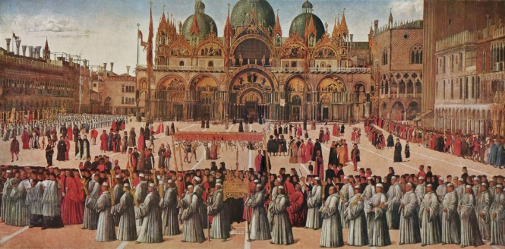

Venice: la Serenissima
At the opening of the 15th century, Venice was enjoying unprecedented wealth and Venice power that it had accumulated in the first decades of the 14t^{h} century. Venice’s holdings on the Italian mainland began to turn a profit and in turn, public patronage of the arts was on the rise. At the same time, the Venetian school of painting had reached the height of its power and influence, a position that it maintained until the last years of the century. In a society as conscious of tradition as Venice, the success of artists depended on their ability to evoke and blend with the glorious past. This golden period of the Serenissima Republic is reflected in the art generated for its churches, confraternities, and palaces.
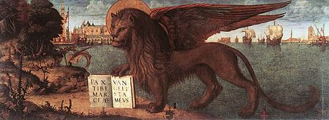
What’s Special:
- Private visit to San Marco after hours
- Special access to the Archives of Venice
- Day in the Venetian Lagoon
- Visit to the Arsenale
- Visit to a Squero
- Lunch of Venetian specialties
Price includes: train ticket, private Lagoon boat, entrance fees and contributions, headsets, lunch on the Lagoon, instruction (NB: does not include hotel).

Transportation:
Wednesday February 12
depart Florence FR 9400 7:30 and arrive in Venice at 9:34
Thursday February 13
depart Venice FR 9457 19:25 and arrive Florence at 21:35
Itinerary
Wednesday February 12: Insider’s Venice and Private San Marco
Follow a maze of alleyways to the Basilica of Santa Maria Gloriosa dei Frari to see important altarpieces by Titian, Bellini, Paolo Veneziano, and Donatello. By special appointment visit the State Archives of Venice and observe up close rare books from the Serenissima Repubblica opened exclusively for our class. Founded in 1478, the Scuola Grande di San Rocco was a confraternity dedicated to caring for the ill, especially plague victims. Discover the importance of confraternities to Venetian society and revel in the over 50 masterpieces lavishly decorating every surface of the confraternity’s interior. In the late afternoon, enjoy a unique experience of exploring a squero, a gondola atelier, and learn about the art of gondola making.
10:35 Arrival in Venice
Walk to Santa Maria Gloriosa dei Frari and drop off bags.
Visit the Basilica of the Frari (works by Titian, Bellini, Paolo Veneziano and Donatello), and the State Archives of Venice
13:00 Break for lunch on your own
Visit the Confraternity of San Rocco (Tintoretto paintings) and a squero.
17:30 Walk Piazza San Marco and break (time to check into your hotels)
Evening
19:00 Meet in front of the Basilica of San Marco for an after-hours visit inside St. Mark’s Basilica. You will have the opportunity to wander slowly through this vast treasure chest of Byzantine and Western art. A first view of San Marco is one of the great experiences of a lifetime and no one can deny that it is among the most beautiful and moving buildings in the world. It has an ethereal quality, conveyed through mosaics, marble and gold, which never fails to surprise the senses with delight and move the viewer emotionally. Golden mosaics cover more than 40,000 square of the domes, walls and floor. At times overwhelming because of its size and beauty, the Basilica is one of the most important buildings in Italy and serves as a vivid reminder of the glories of the Venetian Republic.
20:30 Free for dinner on your own.
Thursday February 13
Science and Secrets of the Venetian Lagoon
Created by three estuaries and protected by a row of sand bars, the Venetian Lagoon stretches 32 miles and includes Venice plus 40 other islands. Explore the fascinating lagoon on this unusual day, which focuses on both history and science. Join Marine Scientist Luca Zaggia and Art Historian, Elaine Ruffolo who will explain Venice’s ecosystem, environmental issues and history. Our day will include visits to some islands that are inaccessible except by private boat, beginning with San Lazzaro degli Armeni, a beautiful Armenian monastery that houses a collection of ancient artifacts, and rare books. Travel through salt marshes of the Bacan area past the Moses project before heading north to the enchanting island of Torcello, to explore its 11th-century church and climb the bell tower for an unforgettable view of the Venetian Lagoon. Explore the little-known island of San Francesco del Deserto, where a Franciscan friar will take us on a tour of the peaceful monastery and enchanting gardens. Lastly, stop at the lovely fishing village of Burano, one of the most photogenic places in all of Italy.
Itinerary
9:00 Meet in front of the Hotel Danieli on the Riva degli Schiavoni
Visit San Zaccheria
Board private boat for day exploring the Lagoon
Morning: Arsenale, island of San Lazzaro degli Armeni and Island of Torcello
13:00 Lunch of Venetian specialties at Ponte del Diavolo in Torcello
15:15 Depart for afternoon visits to island of San Francesco del Deserto e the island of Burano. Boat back to Venice.
19:25 departure from Venice to Florence

