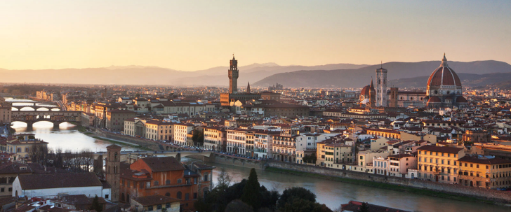

**Florence Art History Class: Masterpieces and Monuments**

**with Renaissance Art Historian Elaine Ruffolo**

**elaineruffolo.com**

**Course Description:**

The course is intended as an in-depth study of art and architecture of the Italian Renaissance, with a special emphasis on Florence.  Each class is devoted to a single topic or decorative complex. All classes are held on-site in a museum, piazza or monument in Florence.

**Class Dates:**

**Wednesday, November 19 Thursday, November 20**

**Tuesday, November 25 Wednesday, November 26**

**Wednesday, December 3 Thursday, December 4**

**Field trip:**

Ravenna Wednesday December 10

**Class time**:

10:00 am to 1:00 pm

**Contact:**

Elaine’s phone number: 339-215-98-51

Kellin Nelson: admin@elaineruffolo.com

**Fees:**

The fee for all six classes is 400 Euros. If you choose to participate on a drop-in basis, the cost is 75 euros per class. Payment is due at the beginning of class in cash (please try to put in an envelope labeled with your name). You can also pay via Zelle (use elaine.ruffolomail.com). If you pay directly on my website using a [credit card](https://donorbox.org/virtual-art-history-encounters-elaine-ruffolo) please be sure to add 3% (77 Euro per class or 412 Euro for the whole series).

Please note, you are responsible for your own entrance fees.

**Useful information:** You may want to purchase a [PassePartout card](https://www.uffizi.it/en/pages/annual-subscriptions) which is good for entry to the Uffizi, Palazzo Pitti and Boboli Gardens for one year. Pass is 71 euros and you can get more information [here](https://www.uffizi.it/en/pages/annual-subscriptions). The office is located at the Uffizi and opens at 10am.

**Suggested reading:**

John T. Paoletti Gary M. Radke, Art in Renaissance Italy (5th edition).

Painting and Experience in 15th century Italy, Michael Baxandall, second edition

Richard Turner, The Renaissance in Florence: the Birth of a New Art, Everyman Library. (Available at the Paperback Exchange on Via delle Oche 2).

**Visits:**

**Wednesday, November 19: Medieval Florence to the Dawn of the Renaissance**

Meet at the column in Piazza della Repubblica at 9:45

Piazza della Repubblica, Bigallo, Palazzo Davanzati, SS Apostoli

Entrance fees: 5.00 Euros for the Bigallo and 9.00 Euro for Palazzo Davanzati

**Thursday November 20: Santa Trinita and the Oltrarno**

Site visit: The Oltrarno: Santa Felicita, Santo Spirito, Santa Maria delle Carmine

Meet at Piazza Santa Trinita in front of the church.

Entrance fee: 10.00 Euro at Santa Maria delle Carmine and 4.00 euro at Santo Spirito

**Wednesday, November 26: Medici Money**

San Marco and San Lorenzo

Meet on the steps of San Lorenzo

Entrance fees: 9.00 Euro at San Lorenzo and 9.00 Euro at San Marco

**Wednesday December 3: Renaissance Sculpture**

Site Visit: Bargello and Orsanmichele

Meet at the entrance of the Bargello, Via del Proconsolo

Entrance fees: 10.00 Euros for the Bargello and 8.00 Euro for Orsanmichele

**Thursday December 4: Masterpieces of the Uffizi**

Site Visit: Uffizi Gallery (meet at door number 1 outside the museum). (This class is limited to 20 participants, please let us know ahead of time if you have an Uffizi pass.)

Entrance fee: 30.00 **Euros**

*The cost of the day trip to Ravenna is circa 230 Euros each per person depending on the number of people attending. We need a minimum of 15 to run the trip.